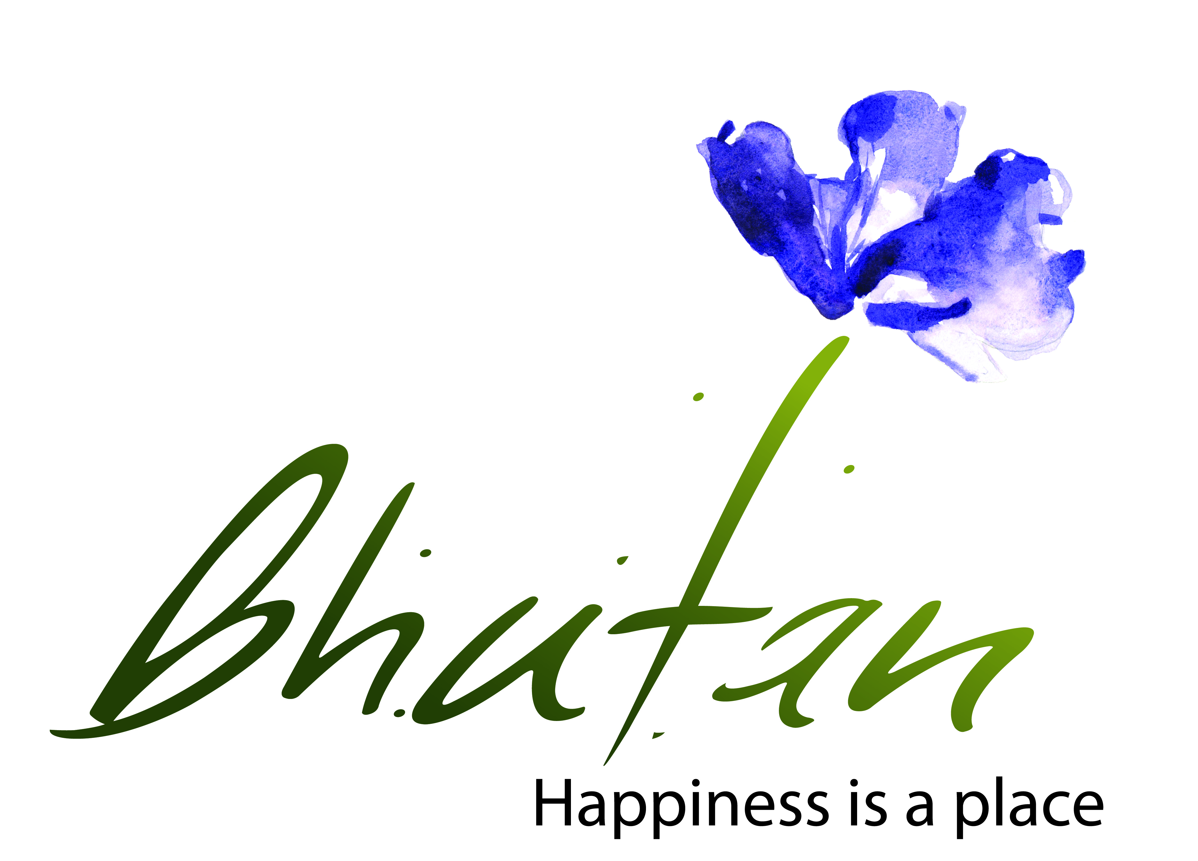 **TOURISM COUNCIL OF BHUTAN**

TRAINING ANNOUNCEMENT

The Tourism Council of Bhutan will be conducting **Driglam Namzha Course for Tour Guides** in **February, 2020** at Royal Institute for Tourism & Hospitality (RITH), Motithang, Thimphu from **03rd - 15th February, 2020** with intake of 100 participants in each batch.

For registration kindly submit the **Registration Form** *(available on our website)* at [training@tourism.gov.bt](mailto:training@tourism.gov.bt). For details please visit our website-**www.tourism.gov.bt**.

**Services Division**

………………………………………………………………………………………………

**Training schedule**

* **03rd - 05th February, 2020**
* **06th – 08th February, 2020**
* **10th – 12th February, 2020**
* **13th – 15th February, 2020**

***Note:***

* Duly filled Registration Form
* Participants to come in formal dress and bring Kabney/ Rachu and Khadar during the training.
* Registered applicants shall attend the full course.
* Working meals and refreshment will be provided
* Time – 9 am – 5 pm